1. org.junit.Assert.*;
   1. fail(“msg”);
      1. Statements after this would not be executed.
   2. assertEquals(expected, actual);
   3. assertTrue(booleanExpression)  
      assertFalse(booleanExpression)
      1. Alternative: assertEquals(Boolean, booleanExpression)
   4. assertArrayEquals(expectedArray, actualArray);
2. org.junit.*;
   1. @Before: For @Test, would run.  
      @After
   2. @BeforeClass, @AfterClass:
      1. Once per class.
      2. Static
3. @Test: The method to be tested.
   1. Should not have more than one condition (assertion).
   2. @Test(expected=RuntimeException.class)
4. Wherever assertion gets failed, later code would not be executed.

Parameterized Test

1. 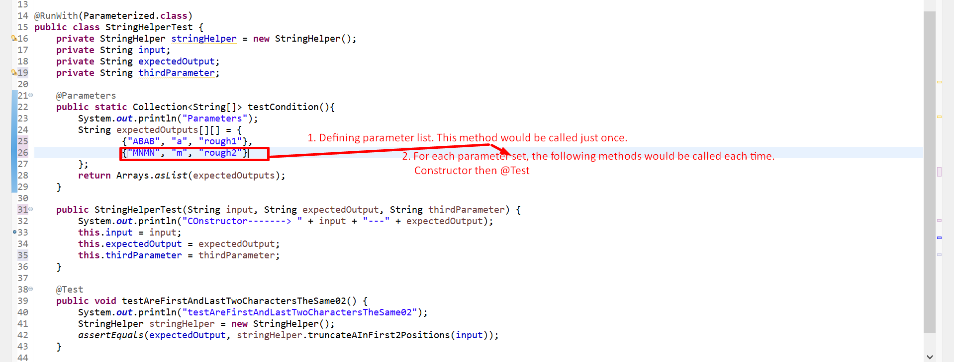 

Suite

1. **Right-clicking package having test cases classes and selecting “Run As” then “JUnit Test” would run all the test cases.**
2. **Suite would run only those which test classes have been added to a suite.**
3. **New 🡺 Other 🡺 JUnit Test Suite 🡺 Then select the classes.**

**import org.junit.runner.RunWith;**

**import org.junit.runners.Suite;**

**import org.junit.runners.Suite.SuiteClasses;**

**@RunWith(Suite.class)**

**@SuiteClasses({ StringHelperParameterizedTest.class })**